The David Lynch Foundation
Healing Traumatic Stress and Raising Performance in At-risk Populations
Programs for schools, prisons, people with HIV or PTSD, victims of violence or historical trauma.
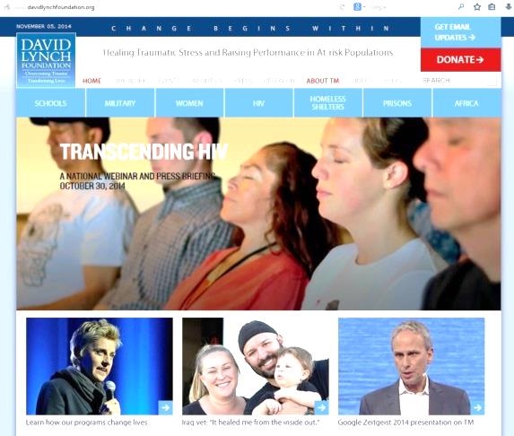
Please join me in supporting the Foundation,
at www.davidlynchfoundation.org
Vic Schoenbach, go.unc.edu/vjs
(please turn over)

The David Lynch Foundation
Healing Traumatic Stress and Raising Performance in At-risk Populations
Programs for schools, prisons, people with HIV or PTSD, victims of violence or historical trauma.
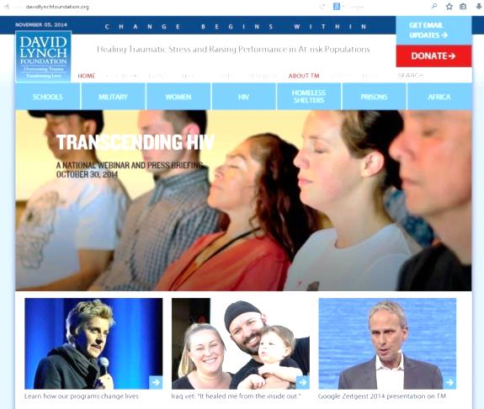
Please join me in supporting the Foundation,
at www.davidlynchfoundation.org
Vic Schoenbach, go.unc.edu/vjs
(please turn over)
The David Lynch Foundation
Healing Traumatic Stress and Raising Performance in At-risk Populations
Programs for schools, prisons, people with HIV or PTSD, victims of violence or historical trauma.
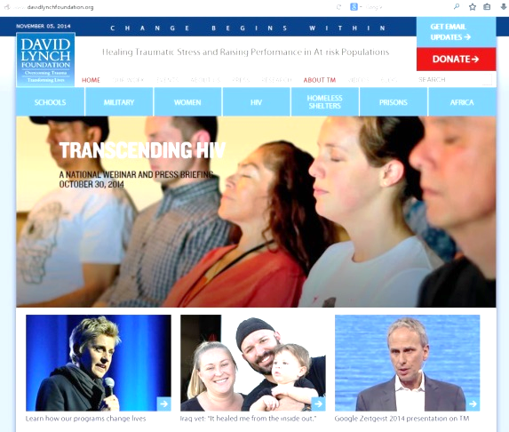
Please join me in supporting the Foundation,
at www.davidlynchfoundation.org
Vic Schoenbach, go.unc.edu/vjs
(please turn over)

The David Lynch Foundation
Healing Traumatic Stress and Raising Performance in At-risk Populations
Programs for schools, prisons, people with HIV or PTSD, victims of violence or historical trauma.
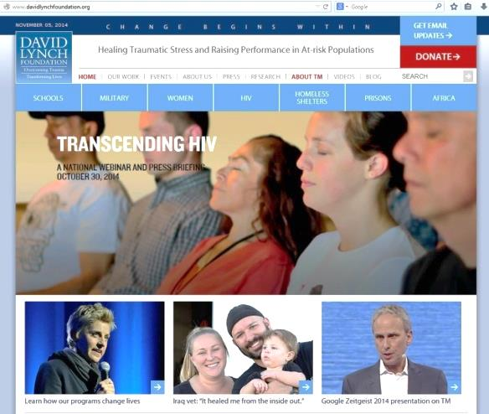
Please join me in supporting the Foundation,
at www.davidlynchfoundation.org
Vic Schoenbach, go.unc.edu/vjs
(please turn over)
“The Quiet Time Program is the most powerful, effective program I’ve come across in my 40 years as a public school educator. It is nourishing these children and providing them an immensely valuable tool for life. It is saving lives.”
—James S. Dierke, Executive Vice President, American Federation of School Administrators
“TM has helped me tremendously—not just in releasing stress, but also increasing my number of T cells. And lowering my blood pressure to the point I no longer need medication.”
–Norma, SF AIDS Foundation client
“After starting TM, my heart and mind were calmed. I had my first full night of sleep in 21 years. I have new goals in my life, and I haven’t stopped smiling ever since my first meditation.”
—Carlos, veteran of Operation Desert Storm and Liberation of Kuwait
“The soldiers tortured me—almost killed me. Now, I feel like it happened to a different woman—not to me. I am a free woman.” – Esperanza, Sudanese refugee
www.ptsdreliefnow.org

(please turn over)

“The Quiet Time Program is the most powerful, effective program I’ve come across in my 40 years as a public school educator. It is nourishing these children and providing them an immensely valuable tool for life. It is saving lives.”
—James S. Dierke, Executive Vice President, American Federation of School Administrators
“TM has helped me tremendously—not just in releasing stress, but also increasing my number of T cells. And lowering my blood pressure to the point I no longer need medication.”
–Norma, SF AIDS Foundation client
“After starting TM, my heart and mind were calmed. I had my first full night of sleep in 21 years. I have new goals in my life, and I haven’t stopped smiling ever since my first meditation.”
—Carlos, veteran of Operation Desert Storm and Liberation of Kuwait
“I love to meditate. I feel happier and I am doing better in school.”
– Lilian, American Indian middle school student
(please turn over)
“The Quiet Time Program is the most powerful, effective program I’ve come across in my 40 years as a public school educator. It is nourishing these children and providing them an immensely valuable tool for life. It is saving lives.”
—James S. Dierke, Executive Vice President, American Federation of School Administrators
“TM has helped me tremendously—not just in releasing stress, but also increasing my number of T cells. And lowering my blood pressure to the point I no longer need medication.”
–Norma, SF AIDS Foundation client
“After starting TM, my heart and mind were calmed. I had my first full night of sleep in 21 years. I have new goals in my life, and I haven’t stopped smiling ever since my first meditation.”
—Carlos, veteran of Operation Desert Storm and Liberation of Kuwait
“I was just so frustrated and full of misguided anger.
I didn’t know where to direct it to. Now people tell me I look very calm. It’s surprising even to me.”
– Howard, formerly homeless man
(please turn over)

“The Quiet Time Program is the most powerful, effective program I’ve come across in my 40 years as a public school educator. It is nourishing these children and providing them an immensely valuable tool for life. It is saving lives.”
—James S. Dierke, Executive Vice President, American Federation of School Administrators
“TM has helped me tremendously—not just in releasing stress, but also increasing my number of T cells. And lowering my blood pressure to the point I no longer need medication.”
–Norma, SF AIDS Foundation client
“After starting TM, my heart and mind were calmed. I had my first full night of sleep in 21 years. I have new goals in my life, and I haven’t stopped smiling ever since my first meditation.”
—Carlos, veteran of Operation Desert Storm and Liberation of Kuwait
“I’m feeling how I felt before I was raped – worthy, lovable, and that I don’t deserve any disrespect in my life.”
– Cynthia, sexual assault survivor
(please turn over)

