Report on the
18th National Health Equity Research Webcast

Social Determinants of Health Disparities:
Moving the Nation to Care about Social Justice
www.minority.unc.edu/institute/2012/
“We all loved the presentations, and were pleased to have access to such nationally respected speakers. I wish everyone in my agency had been in attendance. It's so good and refreshing to hear the truth spoken so clearly about the impact of racism on health.” (Sara Eve Sarliker, site facilitator at the Washington State Dept of Health)

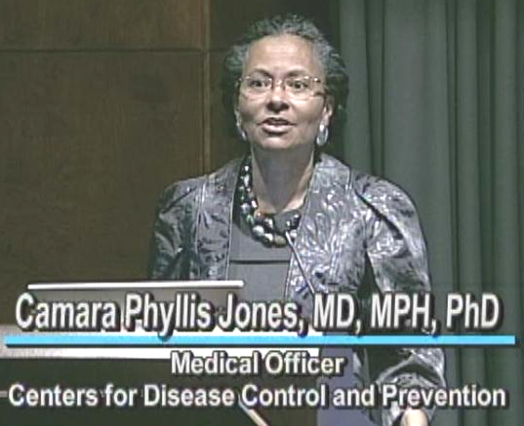
“PLUS: Truly enjoyed the panel diversity and the subject matters covered by each. DELTA: They needed more time! Felt very rushed, especially for Dr. Giachello's presentation. I could've listened to each of them for hours!!” (Lisa Wright-Martin, Norfolk VA)

“Incredible personalities and professionals. Thank you for providing such quality in developing this panel.” (Bryan H, Winston-Salem, NC)

“I appreciated the advance notice of the handouts and slides. It made my experience much better in being able to listen, rather than scramble around to record screen shots and key points.” (Frankfort, KY)

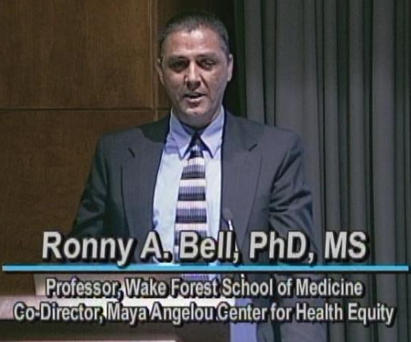

“I love this format! It was almost like being in the room. The speakers were great, and I appreciate that they were all so passionate about addressing the root causes of health problems. Thank you for the opportunity to view these presentations!” (Salt Lake City, Utah)

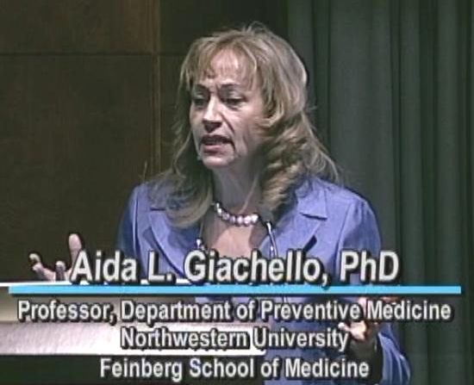
“Comments? Simply that the speakers were very knowledgeable and passionately committed and involved in projects rather than being observers from an intellectual perch. All of them were interesting and good presenters of information.” (Manny Trillo / Mid-America Regional Council / Kansas City Metropolitan Area)

Presenters: Camara P. Jones, MD, MPH, PhD; Ronny A. Bell, PhD, MS; Aida L. Giachello, PhD
(titles and biographies are at www.minority.unc.edu/institute/2012/)

Moderator: Cedric M. Bright, MD, FACP – Director, Office of Special Programs
Assistant Dean for Admissions, UNC School of Medicine
112th President, National Medical Association
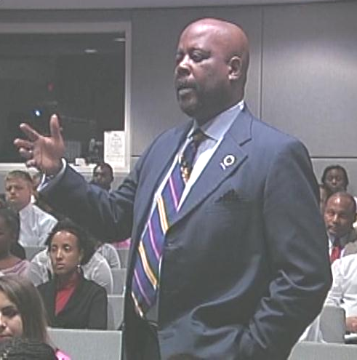
Conference Location and Date: Internet broadcast from the UNC School of Social Work Tate-Turner-Kuralt Building Auditorium, Tuesday, June 5, 2012

Presented by: UNC Gillings School of Global Public Health, Minority Health Project
UNC Diversity and Multicultural Affairs
UNC American Indian Center
Norfolk State University Ethelyn R. Strong School of Social Work, a partner in the Commonwealth Public Health Training Center (PHTC)

Patron sponsor: UNC Gillings School of Global Public Health

Cosponsors: 15 financial, 5 in-kind, 4 partners, plus 6 endorsements
(see list at www.minority.unc.edu/institute/2012/cosponsors.cfm)
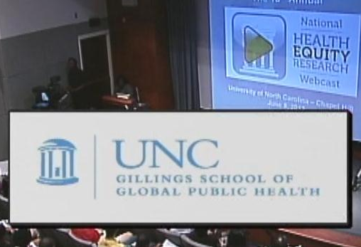
Planning Committee:
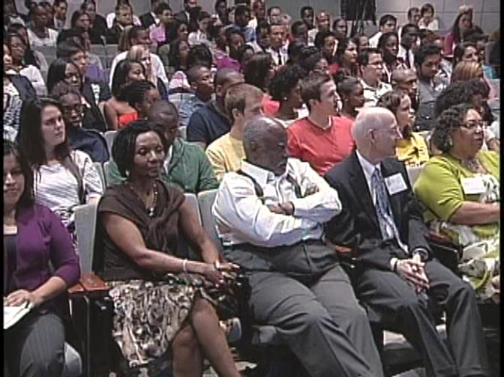
Laika Aguinaldo, Danny Bell, Ronny A. Bell, Kristin Z. Black (co-coordinator), Brandi L. Brooks (co-coordinator), Dorothy Browne, Trenette T. Clark, Alexandra Lightfoot, O.J. McGhee (producer/director), Cookie Newsom (co-chair), Josmell J. Pérez, Victor J. Schoenbach (co-chair), Sharon Holmes Thomas

Additional credits and acknowledgements: www.minority.unc.edu/institute/2012/credits.cfm

Impact indicators:
51 non-UNC websites listed the Webcast as of 6/5/2012.
Estimated live viewing audience: about 2,000
- Over 3,400 unique IP addresses were logged for the NHERW website from March 1st to June 9th, 2012
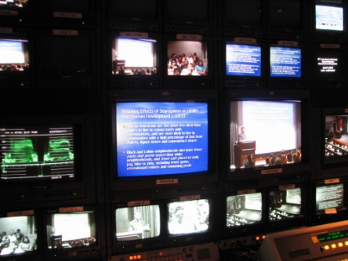
- About 900 unique IP addresses visited the webcast page on the day of the broadcast (the vendor reported that 855 unique IP addresses received the webcast)
- Of these, some 105 would have been group sites and a few more were staff, leaving about 790 for individuals viewing the live webcast
- Projected attendance at 105 group viewing sites, including several in the Commonwealth PHTC: about 900.
- On-site audience at Tate-Turner-Kuralt included 100 MED students, 50 NC-HCAP students, and 84 others (63 preregistered, 21 walk-in) for a total studio audience of 234 viewers. (790 + 900 + 234 ≈ 2,000)

Archived webcast visitors: There have been over 190 visits from 170 different IP addresses to the archived webcast page on the SPH website from 6/8 thru 7/7/2012. About 215 registration forms have been submitted; the 100 registrants who indicated their organization were at an educational or research institution (43%), health department (17%), other government (15%), health care setting (14%), or community organization (9%). Registration forms came from 35 U.S. states plus Ontario and Central America. 80 registrants asked to receive email announcements. Registrants who said how they heard about the webcast listed emails from various sources, social media but mostly MHP email or website. Other sources were health commissioner, faculty, local health department, frontier nursing university, and an alumni magazine. Registration forms for the archived webcast continue to arrive, with some indicating that the webcast has been assigned in a course.
UNC publicity:
http://www.sph.unc.edu/schoolwide_news/unc_to_present_18th_annual_summer_videoconference_on_minority_health_22904_8289.html
The broadcast is listed on the websites of the American Indian Center, Carolina Latina/o Collaborative, Institute of African American Research, NC TraCS Institute
Registration statistics summary

Group viewing sites
Over 100 group viewing sites registered, from 28 states (including Alberta); North Carolina had 31 sites; California was next highest, with 8. Primary locations for sites (Table 1) were educational/ research organizations, local health departments, and other government and municipal agencies, including several in the PHTC Network.

Table 1. Registered group viewing sites, by category
 | N
Educational/ Research organizations | 31
Health Department | 27
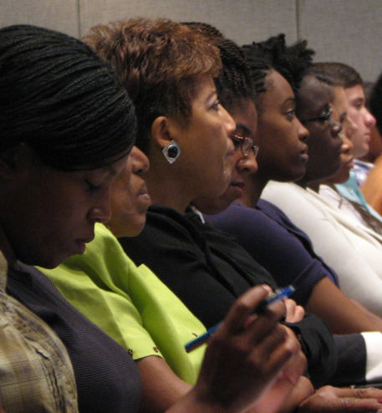  Other government, Municipal Agency | 16
Community Organizations | 10
Hospital, Medical Practice, Nursing Home | 11
Other | 4

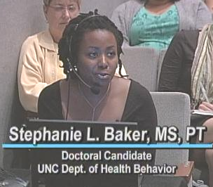
Registered participants

Webcast registrants (n=1,622) came from 49 U.S. states (all except North Dakota), 5 Canadian provinces, and three other countries (UK, France, Mexico). Registrations came primarily from people in education/research organizations (34%), government/municipal agencies (21%), community organizations (15%), health departments (18%), health care organizations (9%).
Selected comments submitted on registration forms:
Thank you for providing your conferences and trainings through webcasts that are free and open to other agencies. You make a valuable contribution to the public health workforce.
Lesley T. Guyot, MPH, CHES

UNC Gillings School of Global Public Health Minority Health Project and UNC Diversity and Multicultural Affairs offers outstanding programs for the school and the community so we can make informed decisions about improving preventative health care.

I really hope that I find a way to attend this very important conference. In California we are not connected with the University, which ignores these kinds of very important conferences. In Monterey County, CSUMB has not embraced Environmental Justice Community organizations, such as ours.

Have viewed these in the past and they have been tremendous. Have bought VCR tapes in past for archive.

Looking forward to this conference presentation as much as any that the Minority Health project has produced.

I am looking forward to hearing from these experts in the field. This is always a valuable event.

Thank you for the opportunity to increase awareness and knowledge for students in health professions and the public. This videocast is co-sponsored by the Bastyr University Simkin Center, Diversity Committee, Center for Student Research and the Department of Midwifery.
Annie Kennedy, Director, Simkin Center

This is a wonderful opportunity for me and the many PhD students in our program, who have viewed past webcasts.

We are a community coalition offering the webinar to our coalition partners. It is open to other local orgs, but there is limited space, so people need to RSVP by emailing the Coalition Coordinator, Chioma Nnaji.

Will this be available by archive? My community health course this summer is for RN's returning for their BSN - most of whom are working and may not be able to access the presentation. Could I request a DVD and permission to share over our Learning Management System (ANGEL)? thanks in advance.

We have shown the webcast the last few years and look forward to showing it again.

I teach Population Based care Primary Care in our Masters program and will be teaching Preventive Care for Populations in our DNP program. I'm looking forward to this broadcast to increase my knowledge on health disparities and some new strategies for reducing them.

This is a can't miss opportunity for those who are interested in eradicating Health Disparities.

This program has been an integral part of our pre-medical and pre-dental summer immersion programming for college students from disadvantaged and rural backgrounds. It has been a key part of our health disparities education curriculum (Northeast Indiana Area Health Education Center - MedPOWER)

Looking forward to it. When teaching public health, I have found previous conferences to be very informative.

I am a recent graduate of San Jose State University with a Bachelor's degree in Health Science with a concentration in Health Services Administration and have worked closely with Native American communities. I am viewing the webcast to further my knowledge of the social determinants of health for minority populations and develop ways to change health status. --Margaret Sotelo

We are a community based organization with a free clinic and other socio economic supportive services for seventeen years combatting health disparities. I am very interested in this webinar. We need to address this together both community and academia.

(comments from participant evaluations are below)
Evaluation response summary

Site facilitators

Completed evaluations were received from 55 site facilitators. All but one reported being able to receive the broadcast. The total viewing count for reporting sites was 550, over 80% of their projected attendance. If viewing sites that did not report their attendance recruited the same percentage of their projection, the total group viewing attendance was over 900.
The 42 site facilitators who provided ratings on the evaluation form gave extremely favorable ones: 98% (41/42) said participants seemed engaged, 95% said participants found the material interesting and important, 74% said the time for presentations was about right (the others said too short), 86% said the time allotted for questions and comments was about right, with the rest nearly evenly divided between too short and too long, 69% said participants felt able to ask questions, 88% said the website was well-organized, convenient, informative, and 90% said that compared to others this broadcast was well organized and run. 41/42 said they would recommend this broadcast to other organizations.

Participants

Online evaluations were submitted by 500 participants (including 332 viewing on a PC, 56 at a group viewing site, 52 in the studio audience). Very few indicated any technical difficulties in viewing.

The overwhelming majority of 438 participants who rated the broadcast were enthusiastic. Nearly all said they either “strongly agree” or “agree” that the:
- "Videoconference increased my understanding of this subject and its relation to public health" (95%);
- "Topics covered were important and relevant to the issue of health disparities" (99%);
- “Videoconference was very valuable for me" (94%); and
- They would "highly recommend the Videoconference" (95%).

Sample participant comments
“as always - love, love, love Camera Jones! Every time I listen to what she is trying to teach me, gives me a 'new side of the prism' to look at all the complexities of intergenerational racism...Dianne, Boston
“The panel diversity was great. Each of the three presentations was robust and informative, and the experts complemented each other well during the Q&A. Dr. Jones was particularly dynamic and compelling It almost felt as if we got a blueprint for moving forward.” (studio audience)
“More time was obviously needed for both the presentation and question segments. There was so much information and dialogue, which was awesome! I very much liked the diversity of the speakers. As individuals passionate about minority healthcare, they added a degree of relevancy and inspiration difficult to encounter in today's world.” Anna Batista, student (studio audience)
(. . . more from the 240 comments follow)
Sample participant comments (continued)
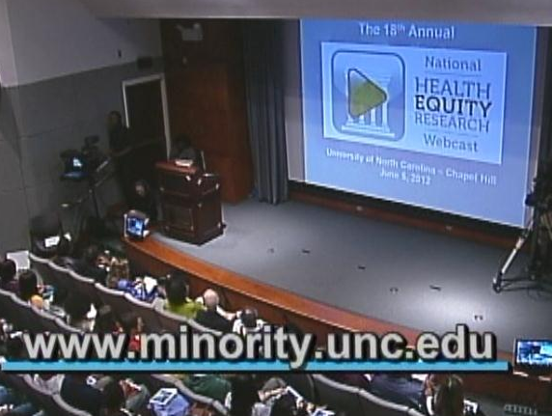
“Eye opening” (webcast participant, PA)

“I found this session to be enlightening. The panelists were very honest and forthright. This was refreshing. Thank you.” Karen Lowe Graham (webcast, IL)

“The presentation were very clear and understandable/topics were clearly defined “
Rosa Browne (webcast participant, CT)

“Dr. Jones was fabulous! A true inspiration!”
(studio audience)

“Incredible personalities and professionals. Thank you for providing such quality in developing this panel.” -- Bryan H (webcast, NC)

“Dr. Giachello seems very knowledgeable of her presentation, and looks like many good things happening in Chicago with Latino community. I would like replication of model on other disparities. Carlos Mejia Ph.D in Public Health student at Walden University. webcast)”

“Simply that the speakers were very knowledgeable and passionately committed and involved in projects rather than being observers from an intellectual perch. All of them were interesting and good presenters of information.” Manny Trillo / Mid-America Regional Council / Kansas City Metropolitan Area (webcast)

“I feel that the need to better investigate issues of health disparities with the minority community is very important to advance the entire community. I think as a social work student at the bachelors level we do not have any courses that focus directly on our involvement in advancing community awareness, organization and creating a system that includes wellness, education and advancements in medicine that actually is making strides within the local community or beyond. / Daniella Harold / BSW Student Norfolk State University (webcast)”

“Dr Camara Phyllis Jones was outstanding- I could listen to her all day.” Annette Dieker (webcast group viewing, WA)

“Great information” (webcast, TX)

“The webcast was very moving for me. Growing up in communities with a majority of white people, I was not aware of the institutionalized setbacks that various races in our country face. I was conditioned to believe that all people had equal footing, and if they did not succeed, it was their own fault. The webcast was very thought provoking and has made me really think about and appreciate the opportunities I've had. I am now motivated to consider these health disparities in our communities as I pursue a career as a doctor. I feel urged to help in the communities where health care and access is less than adequate.”
(studio audience)

“Very well produced. Very interesting speakers. Each speaker could have [filled] one hour.” Laura Daughtery, Ph.D. (webcast, MD)

“As usual top notch presentation that left the listener/participant hoping it could go on.”
Judith Connell, Associate Professor Norfolk State University School of Education (webcast)

“The speakers were excellent. They helped to clarify my own internal thoughts and beliefs.
(webcast, VA)

“This was a great session. It was interesting and educated me on a lot of terms and cultural/societal needs that we need to address both individually and collectively.” (studio)

“I am happy to have had access to such a webcast. It was easy to access, the quality was good, and the sound was excellent. I am glad we are past the presentations about health disparities and how ‘the health of my community is worse than the health of your community.’ I had to endure those divisive attitudes for many years and saw communities pitted against each other fighting for dollars and recognition on the backs of the other communities. Our progression to discussing health equity and social justice is exciting, inspiring and better yet, it is a worthy aspiration to achieve! This webcast was a call to arms and I was grateful for the opportunity to cyber-attend - Graciela Jaschek (webcast, MD)

“A very timely and relevant discussion!” Marina A. Skinner, MBA, Director of Student Advisement, Winston-Salem State University, School of Health Sciences (webcast)

“It would be great if each speaker had more time, even if only 10 extra minutes each. They were all so knowledgeable and passionate, but seemed constrained by time. Extending the webcast by 30 minutes might be a viable option to enhance everyone's experience and understanding on such an important topic.” (webcast, NC)

“Excellent presenters! The only reason I didn't give #4 above the highest rating is that I already know a lot about this topic and the writings of the speakers. They did a great job presenting an important topic. The sad thing is that more people who really need to hear it probably weren't participating.” (webcast, CO)

“I really appreciated Dr. Jones's ‘garden’ story to demonstrate the three levels of racism.”
(webcast, NY)

“love this format! It was almost like being in the room. The speakers were great, and I appreciate that they were all so passionate about addressing the root causes of health problems. Thank you for the opportunity to view these presentations!” (webcast, UT)

“great speaker; will listen to them for hours” (webcast, IN)

“Dr. Camara Jones' explanation of the gardener planting the red and pink flowers gave a powerful visual picture of racism. (webcast, NC)

“Great speakers. I really appreciated the diversity of not only their academic backgrounds, but their cultural backgrounds as well. Really useful information for the Health Care and Public Health fields.” (webcast, FL)

“It was very enlightening! (webcast, SD)

“Camara Jones is an extraordinary researcher teacher who brings great clarity to the issue of racism as a determinant of health disparities. Racism and its impact on health is not a subject that many public health professionals seem eager to engage, but we must be willing to take it on if we ever hope to achieve healthy equity in the United States.” (studio)

“I learned so much from this webcast. It helped me understand that I am sheltered in my equity experience and that I am so very white that it is pathetic. AND, I appreciated the advance notice of the handouts and slides. It made my experience much better in being able to listen, rather than scramble around to record screen shots and key point.” (web, KY)

“Camara Jones is my heroine and I always love relistening to her.” (webcast, WA)

“really enjoyed Dr. Jones -- articulate and convincing. / I also was interested in fetal imprinting concept from Dr. Bell -- and the community outreach of Dr. Giachello (web, OH)

“I found the webcast intellectually stimulating and thought provoking. Sometimes I am so wrapped in my one aspect of epidemiology but this helped me take a step back and look at the big picture.” (webcast, WV)

“I look forward to downloading the slide show because the data represented "illustrates" several issues that often get lost (poverty impacts burden of cancer more than race, etc.)” (webcast, LA)

“I very much appreciated Dr. Jones' simplification of the "cliff" system. Even though I am a public health educator and have learned that information many times, I found that particular presentation fascinating. I'll certainly use it in my work.
“Overall, I though the speakers were wonderful. . . . a wonderful series and so professionally put together. I will certainly recommend that my colleagues view this in the archive.” (webcast, NC)

“I found the organizational framework very interesting. I work in Emergency Preparedness and Response and reach out to community leaders and individuals and was interested in the process of outreach, organization, and functional structure that leads to positive outcomes in the community. . . . Many times everyone throws up their hands and states they can not do something even if they want to because of lack of resources. The resources are there but how do we come together to help each other if the process is not there? The outlines presented in this forum will lead the way to get people to think outside the box and form coalitions to accomplish the impossible”. Gary Davis (webcast, OK)

“Presenters were excellent. I was familiar w/ Dr. Camara J. Jones in relation to the topics of social determinants, health equity and racism because I have been working on improving my knowledge and understanding on those topics and hoping to use this information in my work on the Dane County Fetal & Infant Mortality Team and as my agency strives to use Health Equity as a foundation for our public health priorities and work.” Patricia Frazak
(webcast, WI)

“Overall, it was excellent.” (webcast group viewing, WA)

“The speakers were very clear and concise in their presentations, very informative, and presented the information in a easy to understand format. Dr. Jones' example of the cliff was an extremely interesting way to make the information come alive while showing the seriousness of the problems. The case study provided by Dr. Bell touched my heart in a very profound way. Dr Giachello’s community health workers project, the community that came together to tackle a health issue, the concrete things that can be done was truly inspiring. The web cast was great (webcast group viewing, RI)

